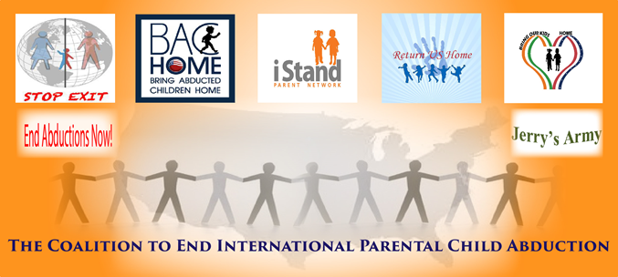

Parent Coalition Warns About Child Abductions during Holidays, Releases Prevention Tips

District of Columbia, Nov. 1, 2016 -- It should be an exciting season, yet the holidays are instead a dangerous time for children who are at risk for kidnapping by a parent. Thanksgiving commences the start of international holiday travel, and a coalition of organizations is warning parents, airlines and authorities to be vigilant to prevent children from being illegally abducted from the United States to a foreign nation.

“We know that this is often a time when a parent can take a child out of the country with relative ease,” said Dr. Noelle Hunter, a spokesperson for the Coalition to End International Parental Child Abduction (IPCA).

“Unfortunately, it’s just too easy to abduct a child from a U.S. airport because of holiday travel traditions, the volume of people moving through airports with international destinations and a lack of exit controls at security checkpoints that would raise red flags about a child leaving the country,” Hunter said.

International parental child abductions may often occur over holidays and summer vacations, and the U.S. State Dept. reports that each year, more than 1000 American children are illegally abducted abroad.
November is International Parental Child Abduction Awareness Month, and Coalition members underscore the importance of parents and communities to be proactive to prevent parental child abductions.

As one element of the seasonal public awareness campaign, the Coalition produced the Parenting Plan Travel Restraint Language & the Prevent Departure Program, a document with suggested language which could be used to write preventive language into custodial or other court documents. Although the material is intended for parents’ general information and not for legal advice, Hunter said these tips may be a helpful first step for parents who suspect their children may be at imminent risk for international abduction by the other parent.

“We recommend parents use this as a guide to seek immediate protections for their children through the courts,” Hunter said.

If there’s imminent risk, parents should contact their local authorities and the State Dept.’s Office of Children's Issues Abduction Prevention Team at 1-888-407-4747,” she said.

The Coalition is comprised of seven parent-led organizations that advocate for the rights of seeking parents and children, justice for taking parents, aiders and abettors, adherence to the international rule of law, and domestic and international policy and legal reform. Its member organizations combine academic, economic, political, legal, cultural and international expertise to drive conversation and action to prevent and end IPCA.

Throughout the month, Coalition parent-advocates will engage with legislators and federal agency officials to advocate for legal and public policy reform to prevent and end IPCA. For more information, contact Hunter at 606-356-8371 or istandparentnetwork@gmail.com.
###

